**Citi-Bike ridership Visualizations - New-York City**

By Ronaldo Migliorini

# Background and considerations:

The source of the data is [Citibike](https://www.citibikenyc.com/system-data). The data chosen for the analysis and comparison was the first 5 months of 2019 and 2020. One of the phenomena to observe is the COVID-19 effect on the ride which is expected due to the knock down of the cities during the pandemic. Other phenomena were expected but not predictable like the COVID-19.

# Comparing Ride Grown 2019-2020

|  |
| --- |
| Phenomena:  Impact of COVID-19 in the Bike Ride during the lock down of the City can be easily identified in the graphic starting in March/2020. At beginning of the year 2020 there is a steady grow compared with 2019 which was interrupted by the COVID-19 starting in March. |

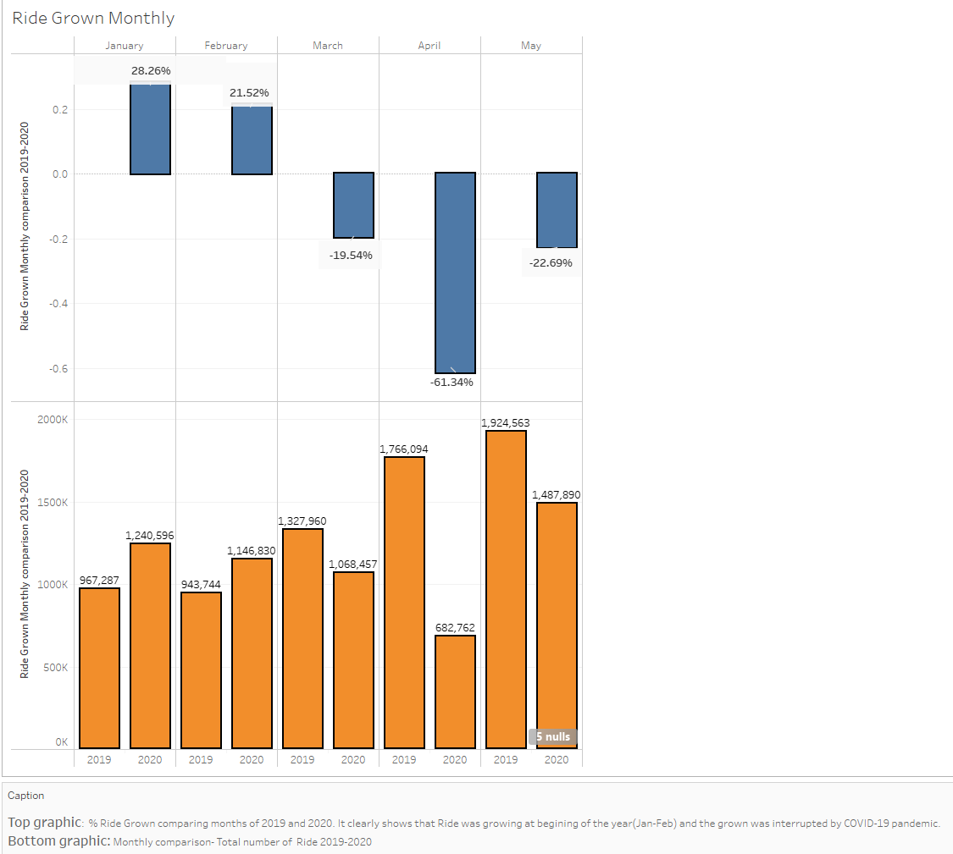

# Understanding Ride duration based on Age Range

|  |
| --- |
| Phenomena:  As expected, young people take long duration trips however the surprise comes with the second place: People in their 50s ride more than all the other age range. Probably because people in their 50s use bike as tool to city seeing and stay health at the same time. |

